**Key requirements of websites**

* User friendly
* Consistent
* Navigational
* Customizable
* responsive

**Quantum computing**

A computing method based on quantum states exploits collective properties to produce computations. Computing quantum computations is the function of a quantum computer.

* Collects data faster.
* Can predict before the process is done.

Advantages:

* Speed
* Useful on big data

**Principles of website design**

|  |  |
| --- | --- |
| Usability | An easy-to-use website has good usability. In terms of usability, it refers to the ease with which visitors can interact with a website |
| White space | The distance between the elements in a composition. This refers to the space between graphics, columns, images, text, and margins. |
| Site layout | The layout of a website defines its structure (or framework). Both the website's owner and users rely on it to structure the information present on the site. |
| accessibility | An accessible website is one that is designed so anyone can use it, even people with disabilities. |
| Navigation | This allows movement from one page to another. Links to other web pages are organized in a navigation menu |
| Typography | Typography comprises 95% of website design. The main task is to make letters and numbers readable and clear. |
| Alignment | Text alignment refers to the positioning of the text on the screen. For example, left align / right align. |
| Clarity | In website design, clarity is how clear and useful something is. |
| Consistency | Consistency makes your work look good by using different elements: headers, footers, sidebars, and navigation bars. |
| Accuracy | Accuracy is how reliable a webpage is and if it is trusted. Also refers to error free and tidy websites. |
| Content | Content in web design is the process of generating support and for promoting. |
| Media & objects | Media and objects can refer to by links and URL hyperlinks. |
| simplicity | Simplicity on website design allows search engines to link to your website. |

**Research how typography is connected to disabilities such as dyslexia?**

Typography links to using font and text size. If someone creates a webpage with a very stylish font or very small font, it can be difficult for people who have dyslexia to read.

**When building a website what font would you use and why?**

* Which fonts are easy to read?

Arial | Times New Roman | Helvetica

* Which size font is best?

|  |
| --- |
| Small 10pt | Normal 12pt | Large 24pt  It is best not use fonts which are novelty or handwriting-like, such as Comic Sans.  **Consider what else you could do as a web developer to ensure that all users can access your webpage regardless of disabilities?**  In my opinion, if I was a website developer, I would include a text to voice converter as the first and most important aspect. The reason for this is because many people with disabilities, especially dyslexia, find it much easier to listen than read. |

___________________________________________________

/\/\/\/\/\/\/\/\/\/\/\/\/\/\/\/\/\/\/\/\/\/\/\/\/\/\/\/\/\/\/\/\/\

------------------------------------------------------------------------------------

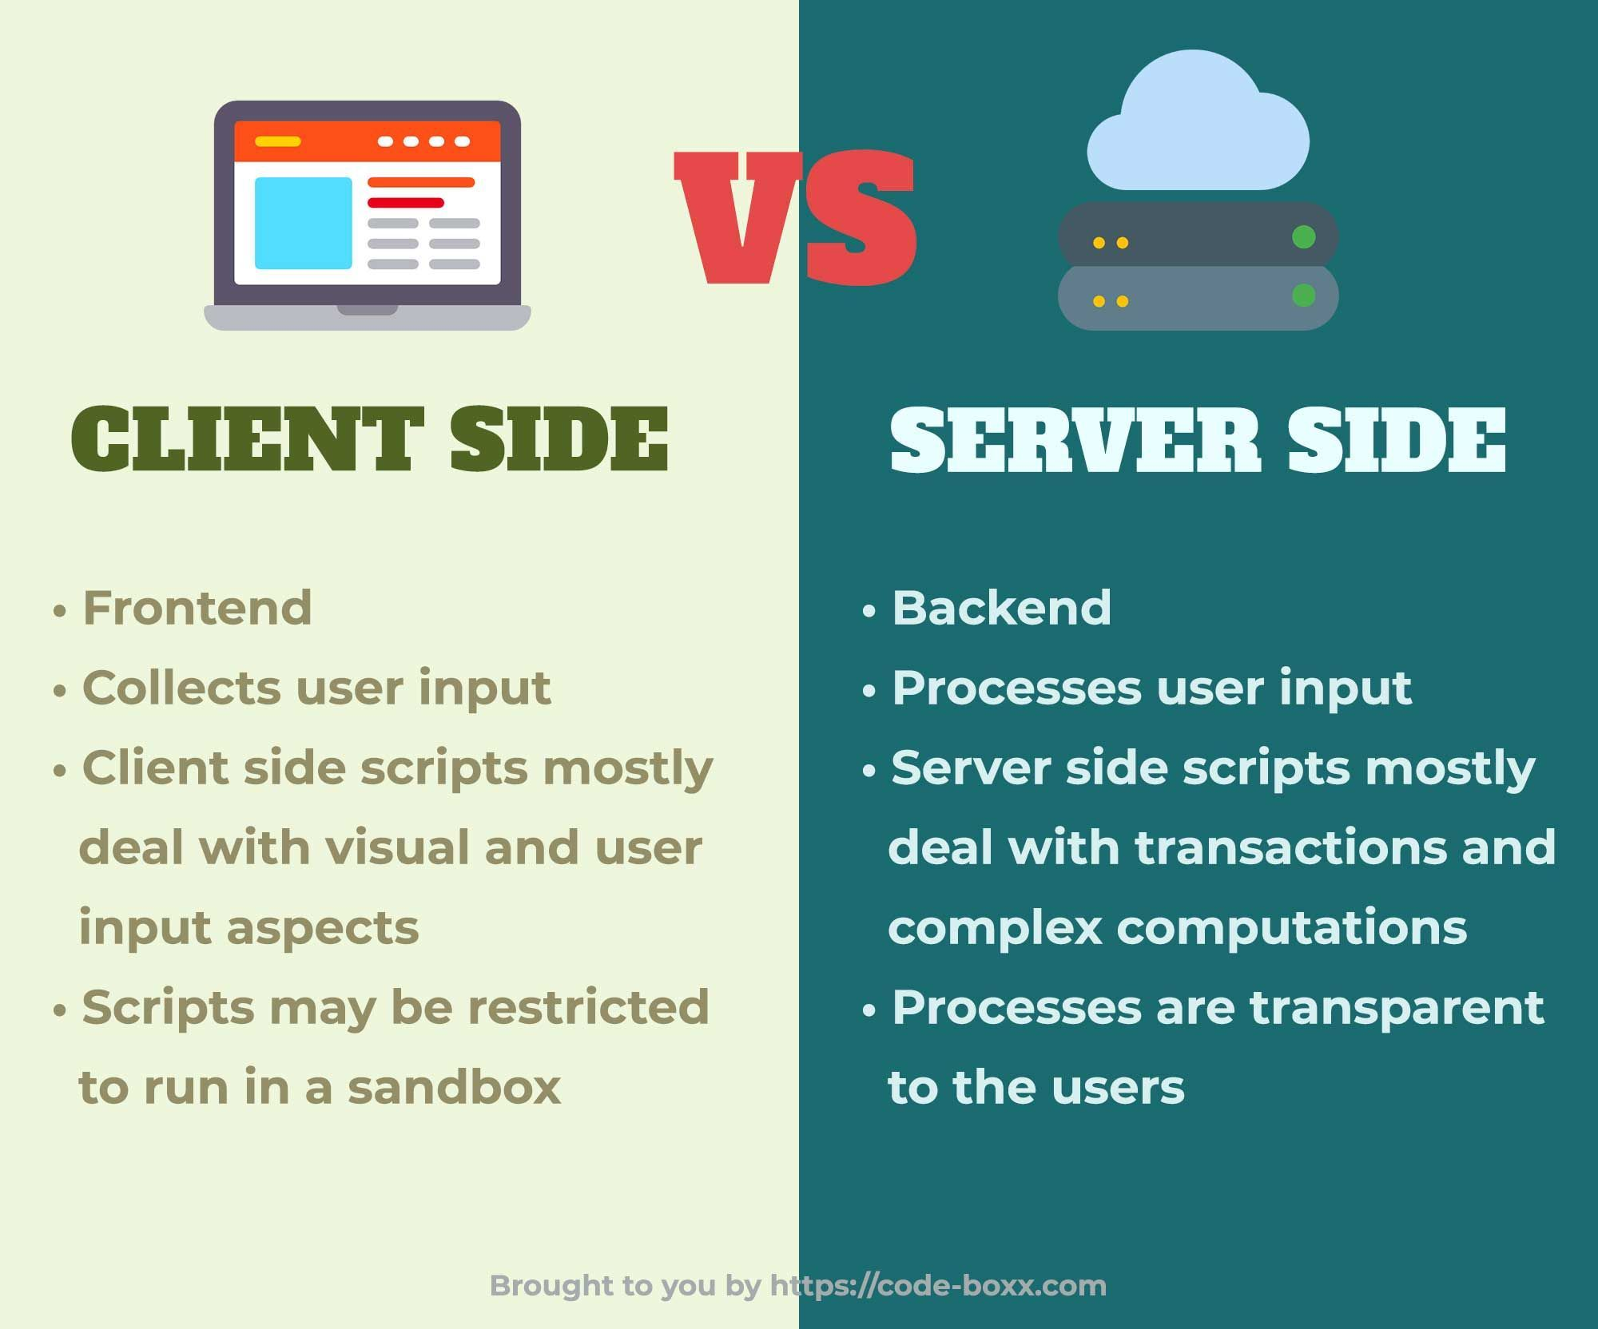 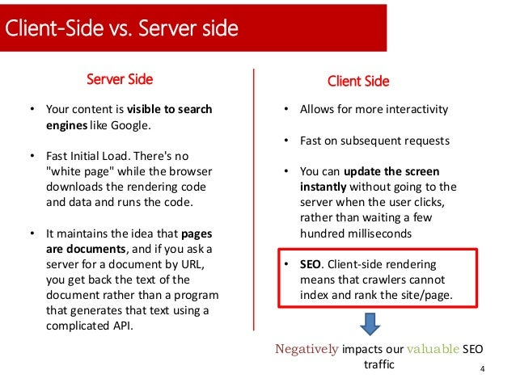

**SERVER SIDE**

* Server-side scripting is used at the backend where the source code is not viewable or hidden at the client side (browser).
* A web server runs the script for server-side scripting that creates the page which needs to be sent to the browser.

**Client side**